

Semester One Examination 2017

Question/Answer Booklet

MATHEMATICS
METHODS UNIT 3

Section Two:
Calculator-assumed

Student Name: _____________________________________

Teacher’s Name: _____________________________________

Time allowed for this section
Reading time before commencing work: ten minutes
Working time for paper: one hundred minutes

Material required/recommended for this section

To be provided by the supervisor
This Question/Answer booklet
Formula Sheet (retained from Section One)

To be provided by the candidate
Standard items: pens(blue/black preferred), pencils(including coloured), sharpener, correction tape/fluid, erasers, ruler, highlighters

Special Items: drawing instruments, templates, notes on two unfolded sheets of A4 paper, and up to three calculators approved for use in the WACE examinations.

Important note to candidates
No other items may be taken into the examination room. It is your responsibility to ensure that you do not have any unauthorised notes or other items of a non-personal nature in the examination room. If you have any unauthorised material with you, hand it to the supervisor before reading any further.

Structure of this paper

 | Number of questions available | Number of questions to be attempted | Suggested working time (minutes) | Marks available | %
Section One  Calculator—free | 8 | 8 | 50 | 52 | 35
Section Two  Calculator—assumed | 14 | 14 | 100 | 98 | 65
 |  |  |  | 150 | 100

Instructions to candidates

- The rules for the conduct of Western Australian external examinations are detailed in the Year 12 Information Handbook 2017. Sitting this examination implies that you agree to abide by these rules.

- Answer the questions according to the following instructions.

Section Two: Write answers in this Question/Answer Booklet. Answer all questions.

Show all your working clearly. Your working should be in sufficient detail to allow your
answers to be checked readily and for marks to be awarded for reasoning. Incorrect
answers given without supporting reasoning cannot be allocated any marks. For any
question or part question worth more than two marks, valid working or justification is required to receive full marks. If you repeat an answer to any question, ensure that you cancel the answer you do not wish to have marked.

It is recommended that you do not use pencil, except in diagrams.

- You must be careful to confine your responses to the specific questions asked and to follow any instructions that are specific to a particular question.

- Spare pages are included at the end of this booklet. They can be used for planning your responses and/or as additional space if required to continue an answer.
- Planning: If you use the spare pages for planning, indicate this clearly at the top of the page.
- Continuing an answer: If you need to use the space to continue an answer, indicate in the original answer space where the answer is continued, i.e. give the page number. Fill in the number of the question that you are continuing to answer at the top of the page.

- The Formula Sheet is not handed in with your Question/Answer Booklet.

Section Two: Calculator–assumed 98 marks

This section has fourteen (14) questions. Attempt all questions. Write your answers in the spaces provided.

Spare pages are included at the end of this booklet. They can be used for planning your responses and/or as additional space if required to continue an answer.

- Planning: If you use the spare pages for planning, indicate this clearly at the top of the page.
- Continuing an answer: If you need to use the space to continue an answer, indicate in the
original answer space where the answer is continued, i.e. give the page number. Fill in the
number of the question(s) that you are continuing to answer at the top of the page.

Working time: 100 minutes

Question 9 (8 marks)

Kim drives through three intersections with traffic lights on her way to work each morning. The traffic lights have been synchronised to allow traffic to flow more easily. The random variable, X, indicates the number of green lights Kim drives through. The probability distribution is given below.

x | 0 | 1 | 2 | 3
 | k | 2k | 3k | 4k

(a) Show that k = 0.1. (1 mark)

(b) State the probability that Kim goes through at least 2 sets of green lights. (1 mark)

(c) Kim drives to work on two consecutive days. What is the probability that the number of traffic lights that are green is the same on both days? (2 marks)

(d) Determine the variance of X, Var(X) and the expected value of X, E(X). (2 marks)

(e) Find 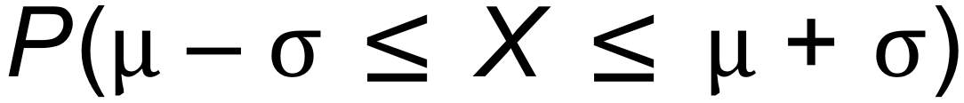, where  is the standard deviation of X (2 marks)

Question 10 (10 marks)

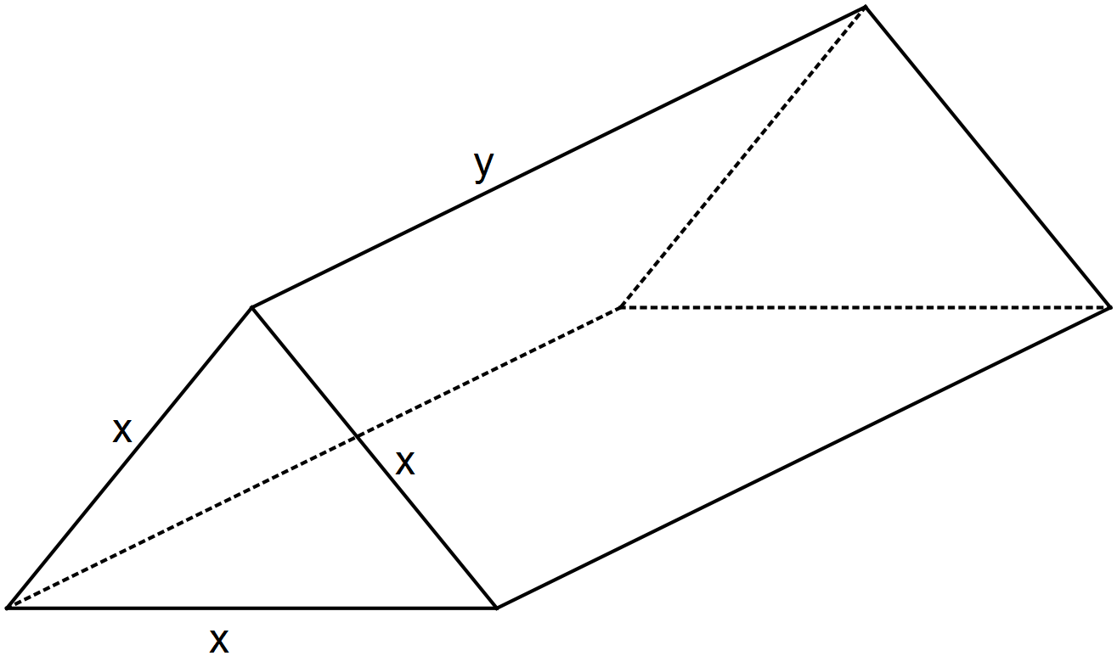A triangular prism has a volume of 1000 cm³. The ends are equilateral triangles with side length x cm and the length of the prism is y cm.

(a) Show that 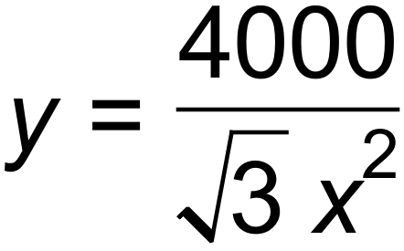 . (2 marks)

(b) Show that the total surface area, SA cm², of the prism is given by 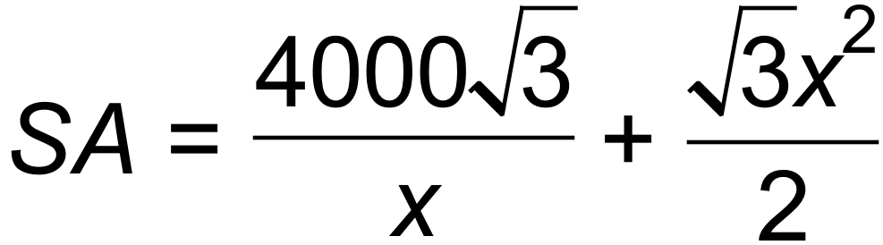.
(3 marks)

(c) Use calculus techniques to find the dimensions of the prism with a minimum surface area.
Verify that it is a minimum. (5 marks)

Question 11 (7 marks)

An oven is pre-heated to 190°C in order to cook a roast for dinner. The temperature of the roast T,
in °C, after h hours in the oven is given by .

(a) (i) Determine the initial temperature. (1 mark)

(ii) Show that 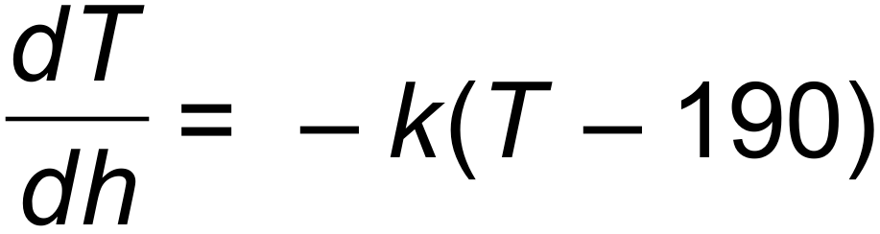. (3 marks)

(b) The roast is placed in the oven at 3 pm. At 4 pm it reaches a temperature of 29°C. It will be cooked when it reaches a temperature of 80°C. At what time will it be cooked?
(3 marks)

Question 12 (11 marks)

A Perth Glory player is practising kicking goals. He has a probability of  of scoring a goal when he kicks at the goal box. He repeatedly attempts to kick a goal.

(a) Explain why each goal attempt is a Bernoulli trial. (2 marks)

(b) If Y is the Bernoulli random variable of kicking and scoring a goal, find:

(i) E(Y). (1 mark)

(ii) Var(Y). (1 mark)

(c) If the player kicks at the goal five times, find the probability of:

(i) missing every time. (1 mark)

(ii) scoring a goal exactly once. (2 marks)

(iii) scoring a goal at least twice. (2 marks)

(d) What is the smallest number of attempts the player should make to ensure a
probability of more than 0.95 of scoring a goal at least once? (2 marks)

Question 13 (5 marks)

(a) Evaluate 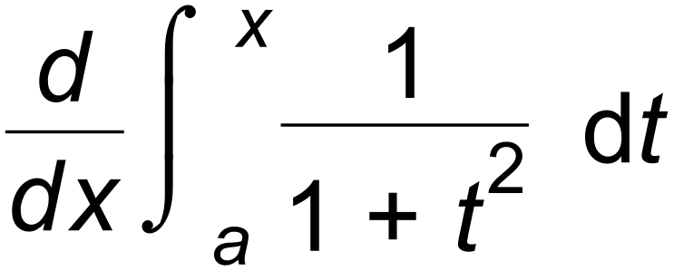 where a is a constant. (1 mark)

(b) Find 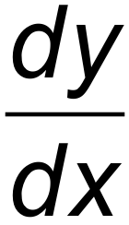 if 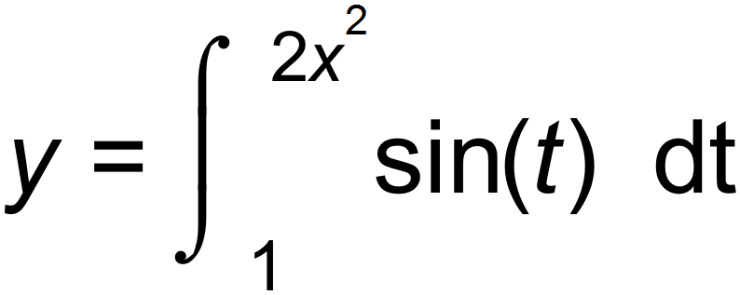. (2 marks)

(c) Determine for what value(s) of x the following integral has a stationary point. (2 marks)
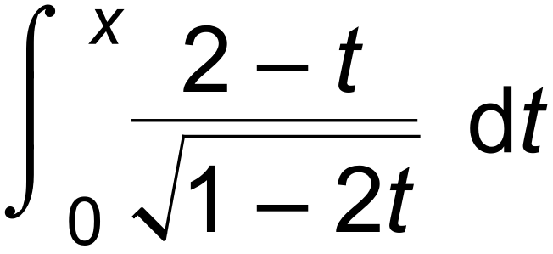

Question 14 (7 marks)

(a) Y is a discrete random variable with a binomial distribution. The expected value of Y is 7.5 and the variance of Y is 5.25. Find the values of n, the number of trials, and p, the probability of success. (3 marks)

(b) A computer network consisting of 20 computers is warned about a virus which is attacking systems. The virus enters each computer with a probability of 0.4 independently of other computers.

(i) State the parameters of the distribution and find the probability that the virus
enters at least 10 computers. (2 marks)

(ii) The ITC manager checks each computer, one after another, to see if it is infected with the virus. What is the probability that the 6th computer she tests is the first one that is infected? (2 marks)

Question 15 (7 marks)

(a) Show that the area bounded by 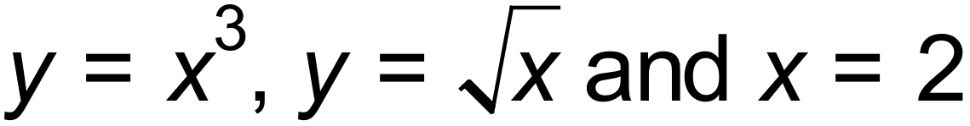 is 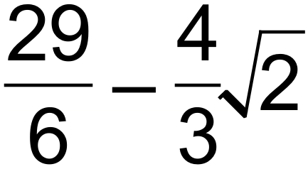 units². (3 marks)

(b) Find the exact area of the shaded region. (4 marks)
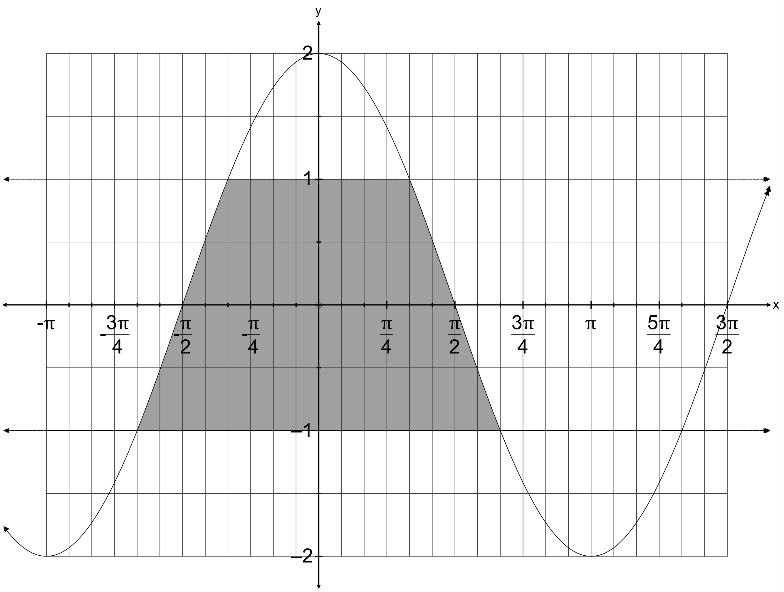

Question 16 (5 marks)
The area, in cm² , of a segment is given by 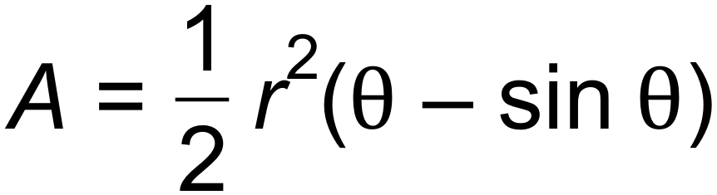 where r is a constant..

(a) Use the incremental formula to estimate the change in area, in terms of r, as  is
increased from  to  radians. (3 marks)

(b) Use your answer from (a) to estimate the percentage change of the area,
correct to 3 significant figures. (2 marks)

Question 17 (7 marks)

The half-lives of radioactive elements can be used to date events from the Earth’s past using the relationship 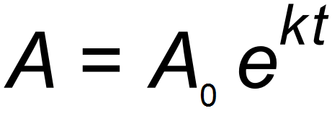, where A is the amount of Carbon−14 present at any time t years.

Since the half-life of carbon-14 is known to be 5700 years, it is possible to compare the proportions of carbon-14 remaining to that which was originally present, to find out the age of organic samples.

(a) Show that . (2 marks)

(b) Find the age of a sample in which 10% of the carbon-14 originally present has decayed.
(2 marks)

(c) A painting signed by a famous painter is carbon-14 dated by experts. The painting
contains 99.5% of its original carbon-14. Justify mathematically why the painting is
not 300 years old as claimed. (3 marks)

Question 18 (3 marks)

The marginal cost function for producing x electronic components per day is
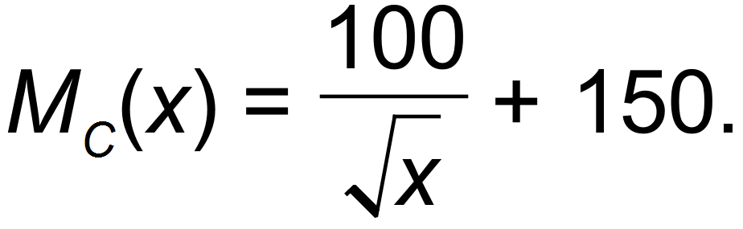
Determine the cost of increasing production from 100 components per day to
400 components per day. (3 marks)

Question 19 (7 marks)

(a) Use the quotient rule to show that gradient function of 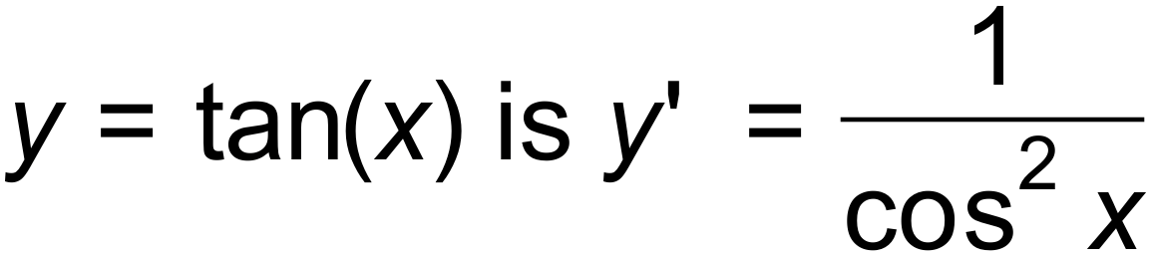. (3 marks)

(b) Sketch the gradient function,  on the same set of axes below. (2 marks)

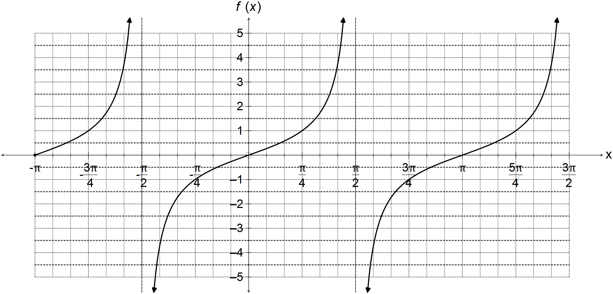

(c) Determine 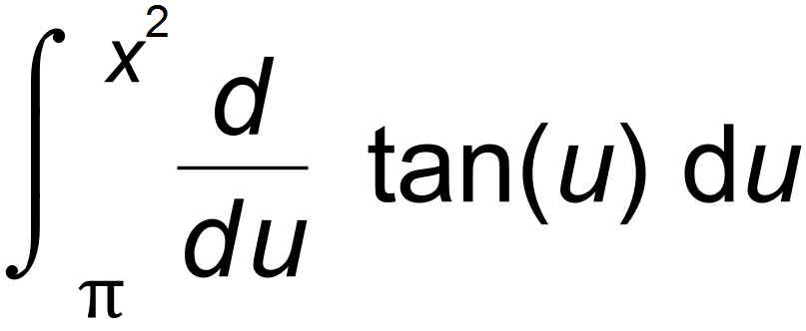. (2 marks)

Question 20 (9 marks)

The acceleration of a particle is given by 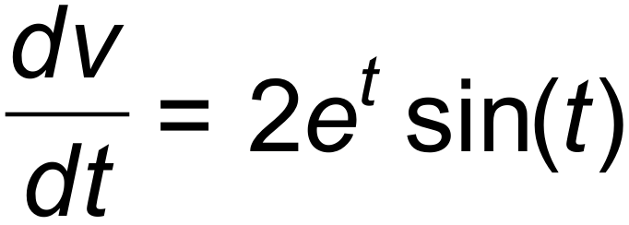 in m/sec² for . It is known that 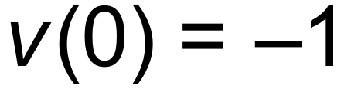 and that the displacement at 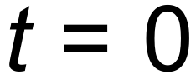 is 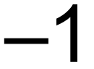 m.

(a) Find the velocity of the particle at 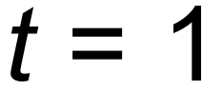. (3 marks)

(b) After how many seconds does the particle change direction for the first time? (1 mark)

(c) Determine the displacement of the particle at t = 3. (3 marks)

(d) Find the distance covered between 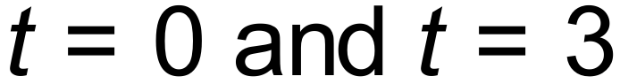 to the nearest m. (2 marks)

Question 21 (8 marks)

A service centre manager records the time required for a particular service consultant, to assist 200 customers. The data is given in the table below with times rounded to the nearest 3 minutes.

Time, X (in minutes). | Number of customers | Relative frequency
3 |  | 0.43
6 | 42 | 0.21
9 | 32
12 | 16
15 |  | 0.12

(a) Complete the table above. (2 marks)

(b) The centre manager states that if the average time to assist a customer is more than 6 minutes, the service consultant needs further training. Does the service consultant need further training? Justify your answer. (2 marks)

(c) Find:

(i) 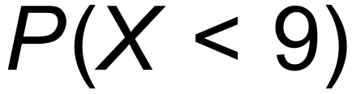 (1 mark)

(i) 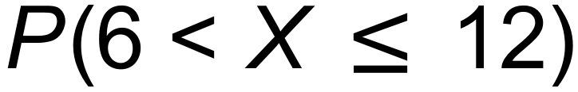 (1 mark)

(ii) 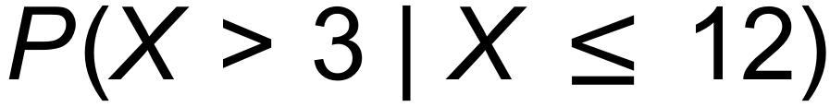 (2 marks)

Question 22 (4 marks)

Consider the function 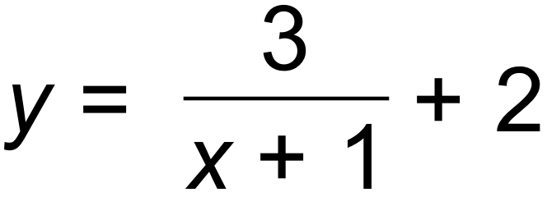 graphed below.
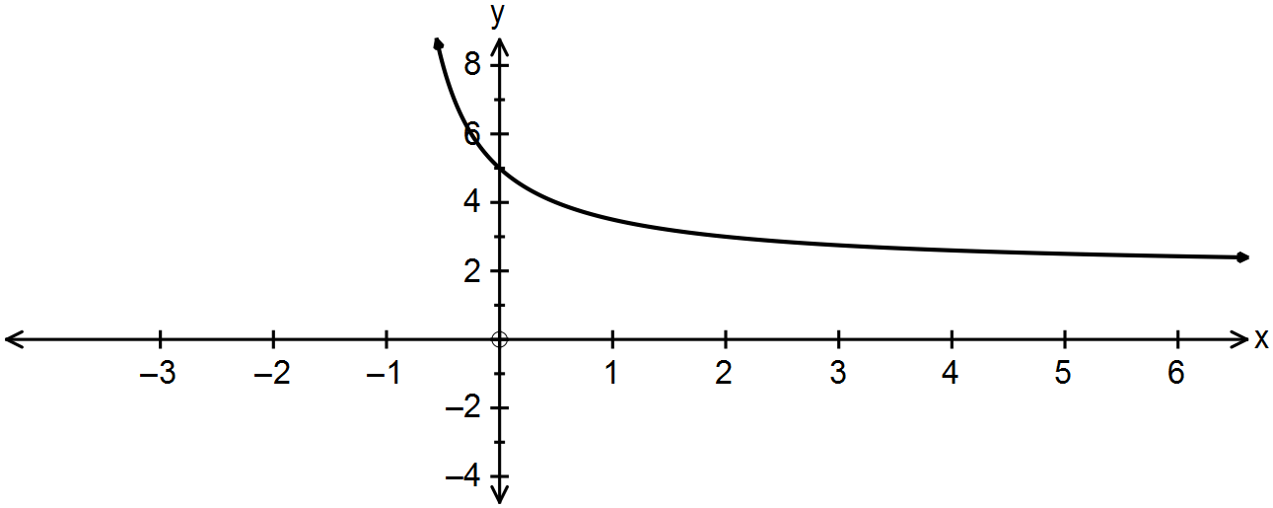

(a) Complete the table of values: (1 mark)

x | y
0
1
2
3
4

(b) Use 4 upper rectangles and 4 lower rectangles to approximate the area under the
curve from . (3 marks)

END OF QUESTIONS

Additional working space

Question number(s): ……………………

Additional working space

Question number(s): ……………………

WATP acknowledges the permission of School Curriculum and Assessment Authority in
providing instructions to students.

